2403A54100

G.Sai kiran

Lab test – 1

Task: Write two different prompts to get a summarized news report from an AI model.  
o One with poor context.  
o One with detailed context (e.g., specify tone, target audience, and summary length).  
• Compare the outputs and explain which is more effective and why.

Prompt 1: Poor Context

Summarize this news article

Generated code and output:

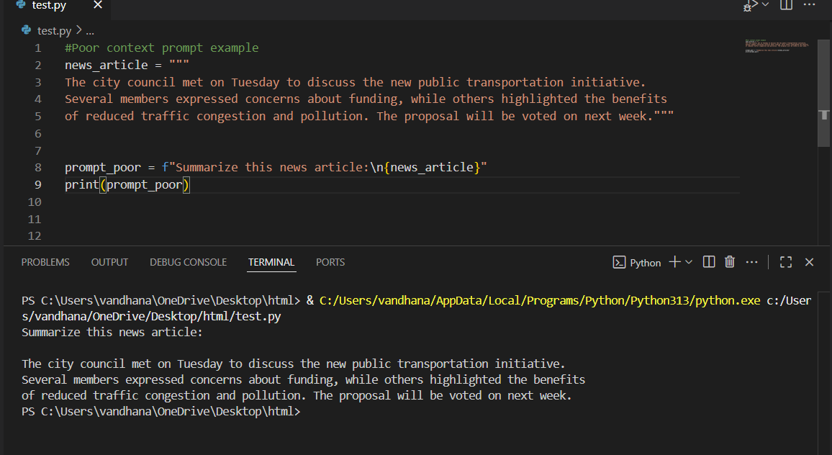

Explanation :

This code creates a simple prompt for an AI to summarize a news article, but with poor context.

• The news_article variable stores the article text.

• The prompt_poor variable forms a prompt by asking "Summarize this news article:" and appending the article.

• print(prompt_poor) displays the prompt. Because the instructions are vague, the AI may not know the desired summary length, tone, or target audience, which can lead to inconsistent or less useful summaries.

Prompt 2: Detailed Context

Summarize the following news article in 3-4 sentences, using a neutral and informative tone. The summary should be suitable for high school students and highlight the main events and their significance.

Code generated and output:

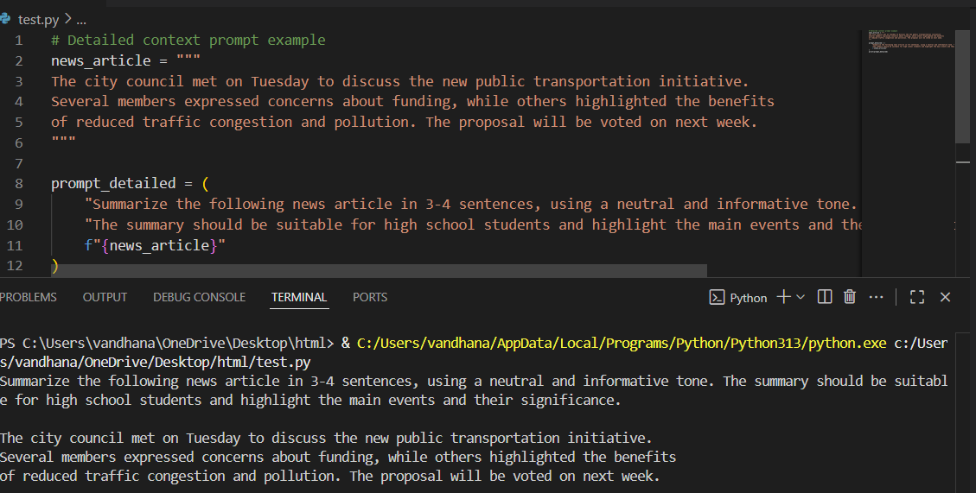

Explanation of code:

This code creates a detailed prompt for an AI to summarize a news article.

• The news_article variable contains the article text.

• The prompt variable combines instructions (about tone, audience, and summary length) with the article content.

• The instructions ask the AI to write a 3–4 sentence summary, use a neutral and informative tone, and make it suitable for high school students.

• print(prompt) outputs the full prompt, ready to be sent to an AI model for summarization.

This approach helps the AI generate a summary that matches specific requirements.

comparison:

The detailed context prompt is more effective because it guides the AI on tone, audience, and summary length, resulting in a summary that is clear, concise, and appropriate for the intended readers. The poor context prompt is vague, so the AI may generate a summary that is too brief, too detailed, or not suitable for the target audience.

**Q2. Multi-Turn Prompting Design**   
• Scenario: You are designing a chatbot for customer support.  
• Task: Write a sequence of 3 prompts where each uses the previous response as context (conversation continuity).  
• Evaluate how context improves the AI’s accuracy.

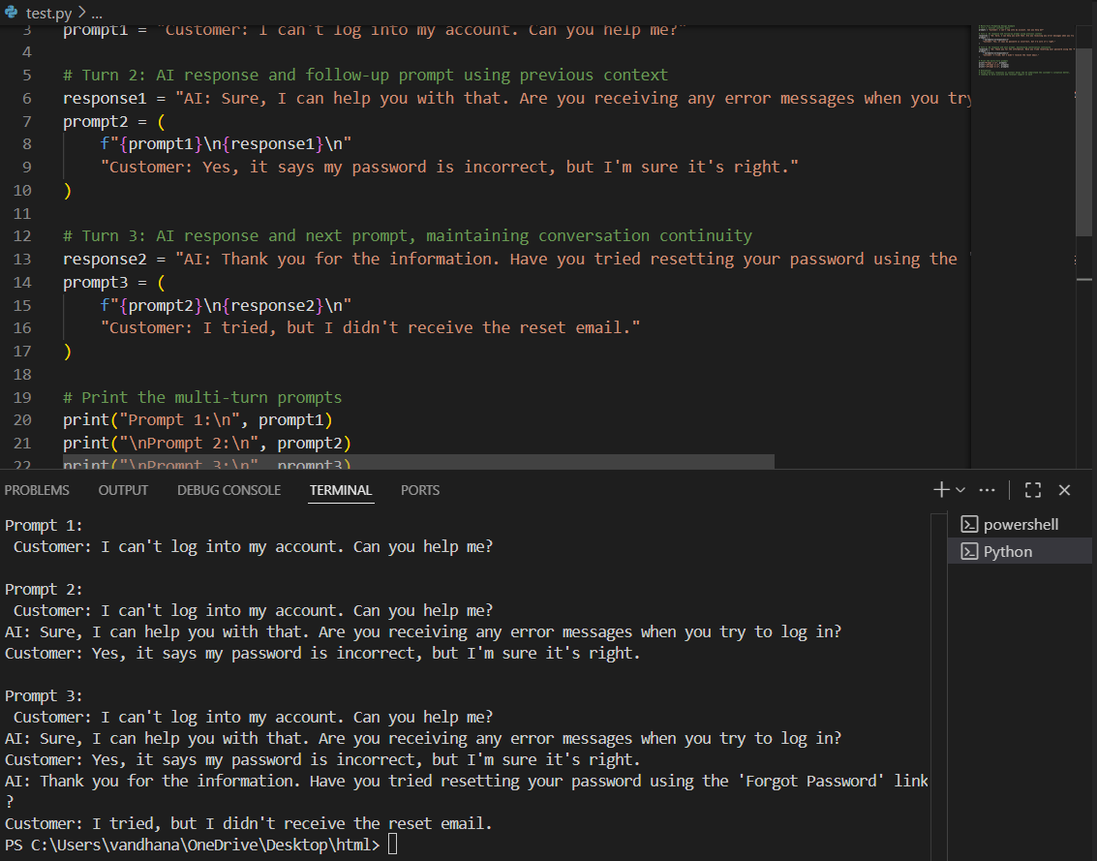

* **Evaluate how context improves the AI’s accuracy**

Including previous conversation turns as context allows the AI to track the user's issue and responses, leading to more accurate and relevant answers.

With context, the AI can avoid repeating questions, address specific problems (like password reset issues), and provide step-by-step support.

Without context, the AI might give generic or redundant replies, missing important details from earlier in the conversation.

Thus, context continuity improves the AI’s understanding and the overall quality of customer support